Course: MMDS

*Lab 01*

**Set up Hadoop**

***Fill answers of the questions below in the given tables.***

***Your screenshots must contain commands for required operations.***

## Question 1:

Set up Hadoop following this [tutorial](https://docs.google.com/document/d/11SAKiH05INO3tP91iUAuoqEnpSzS3Bg1AQfcCliD-jo/) and then take a screenshot of the hdfs-site ([localhost:9870](http://localhost:9870)) which shows information for NameNode Journal Status, NameNode Storage, DFS Storage Types (Overview page).

For example,

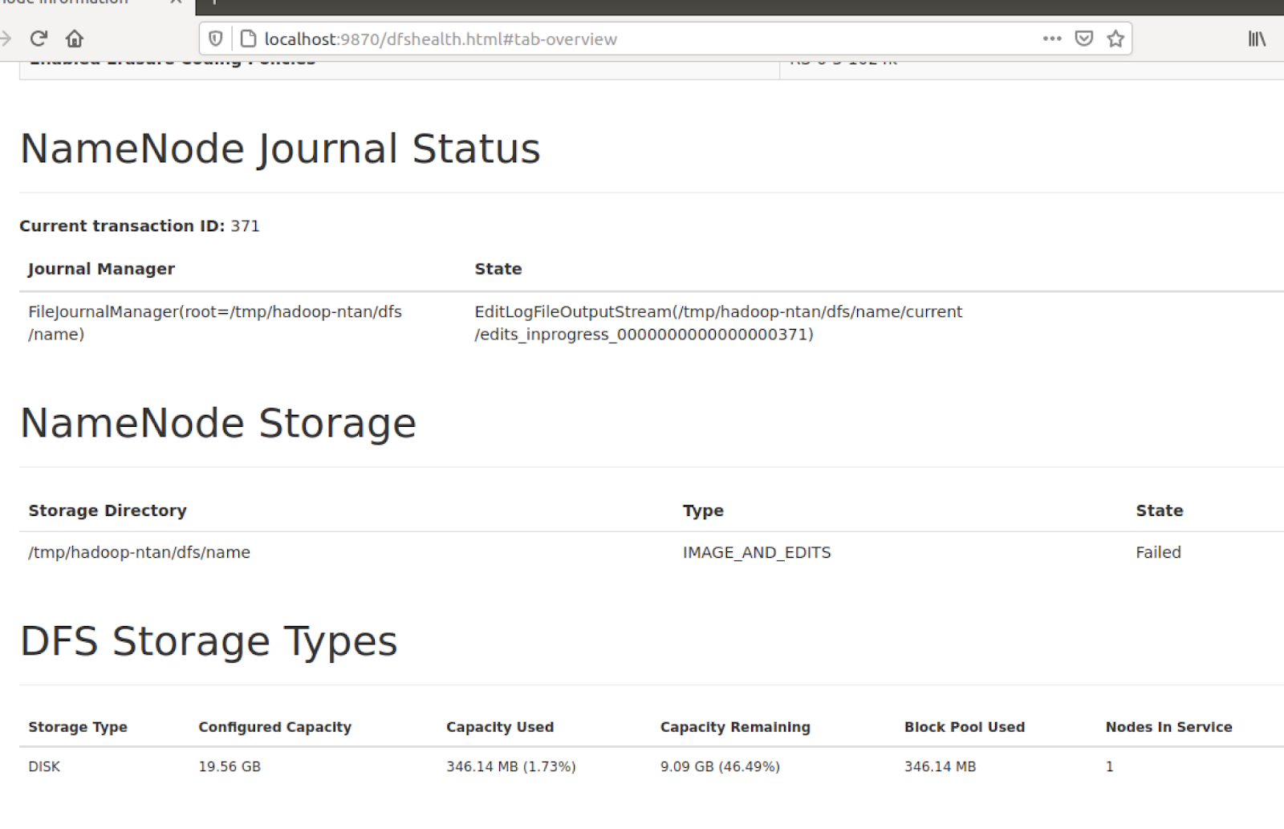

|  |
| --- |
| *My screenshot:* |

## Question 2:

Set up Hadoop following this tutorial and then take a screenshot of the yarn-site ([localhost:8088](http://localhost:8088)) which shows information for nodes (<http://localhost:8088/cluster/nodes> ).

For example,

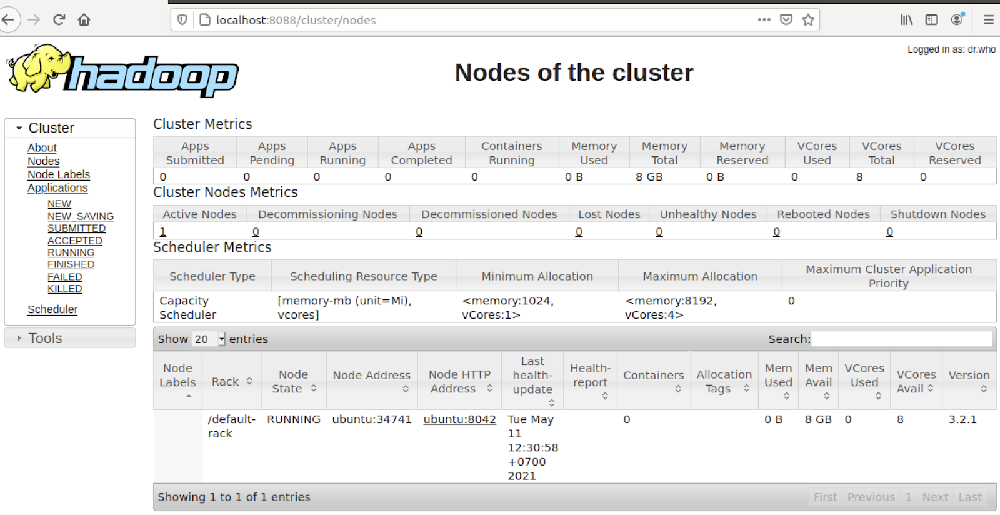

|  |
| --- |
| My screenshot: |